**Install instruction for Mac OS for installing MySQL .**

**Mac Requires two software’s to be downloaded.**

1. **MySQL database Server**
2. **MySQL workbench**

**MySQL Database Server Setup**

**Download Locations:**

***OPTION 1 :*** I have already downloaded to My google drive, Please use this link.

<https://drive.google.com/file/d/1S7w1SWiBcNujcyD7mizQGdUMiBr0Cmmn/view?usp=sharing>

**OPTION 2 :** If the link has any issue, use the following original location to get the software. You will be asked to create an account with oracle.com when you download the software.

<https://dev.mysql.com/downloads/mysql/>

Click on first Choice ( macOS 10.15(x86,64-bit) , DMG Archive ) to download

<https://dev.mysql.com/downloads/file/?id=497036> ( use direct link if you cannot find mac)

NEW VERSION is 8.0.30

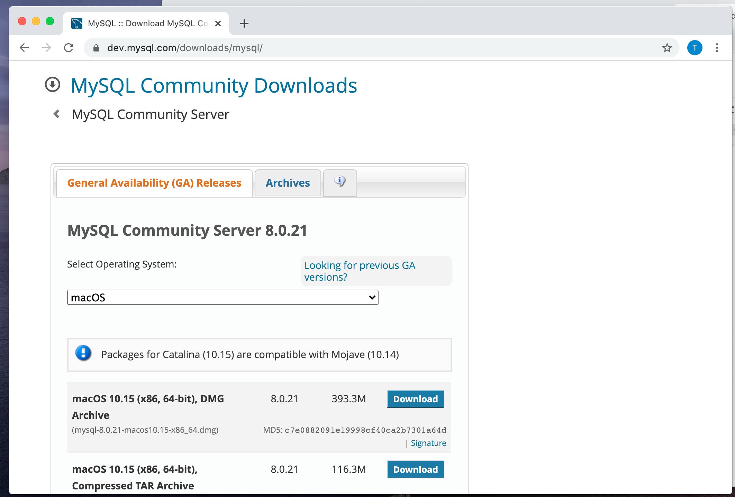

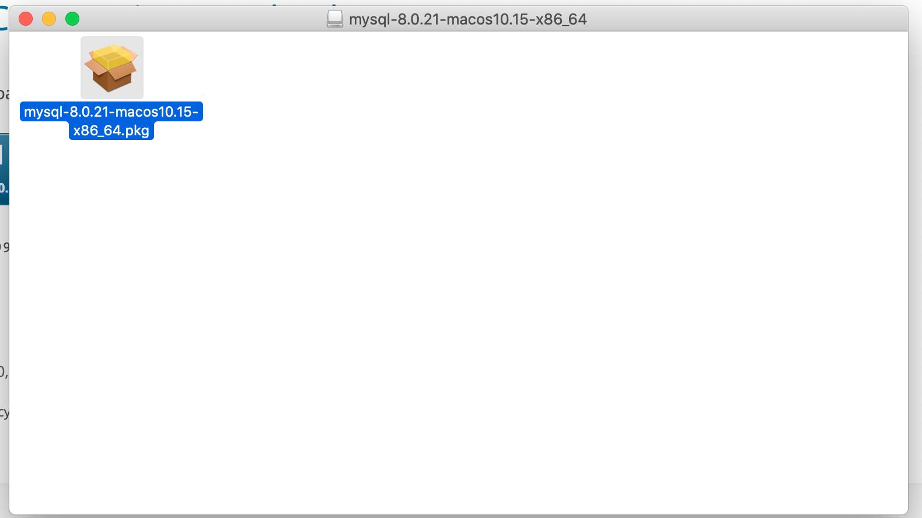

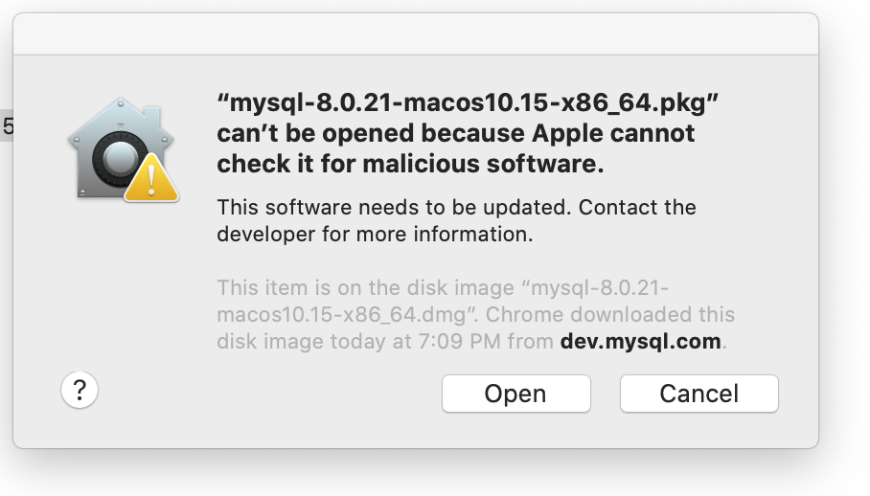

If you get above message and not able to open the file, go to

System Preference -> Privacy & Security -> General Tab will have message asking to “open file anyway”

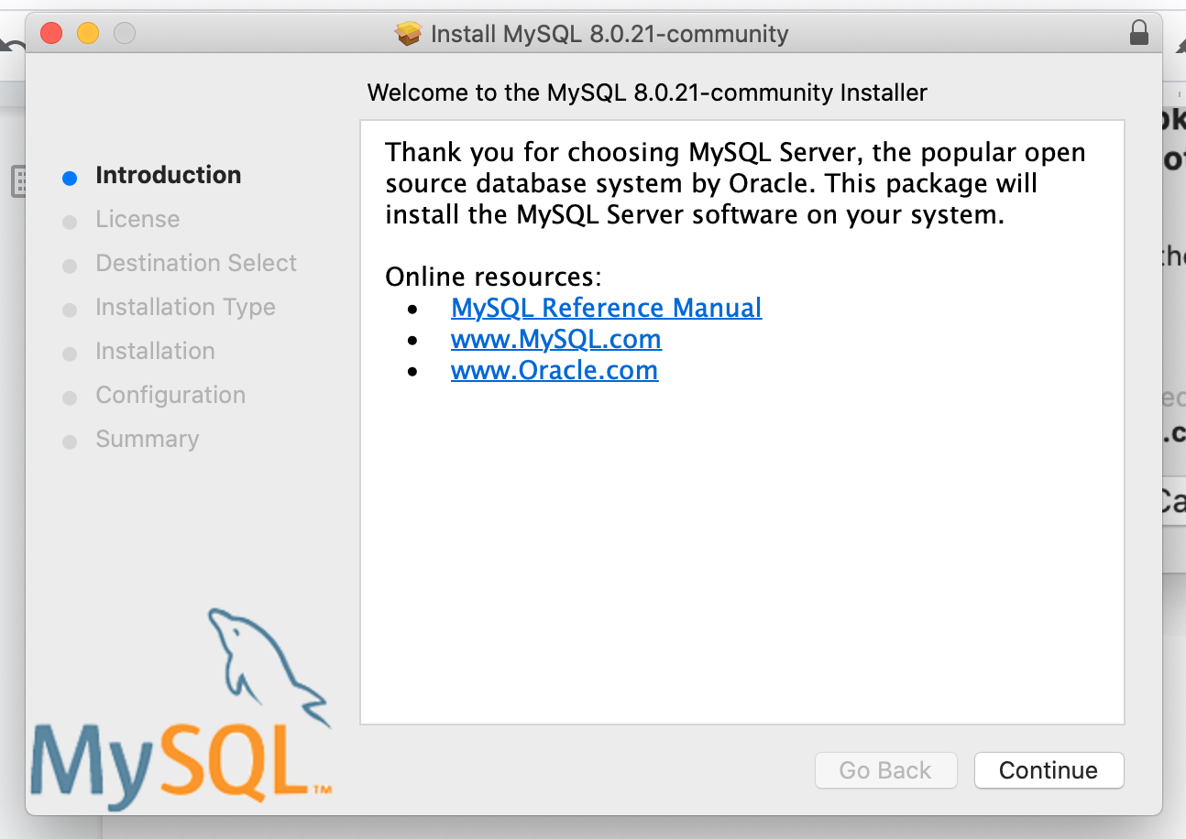

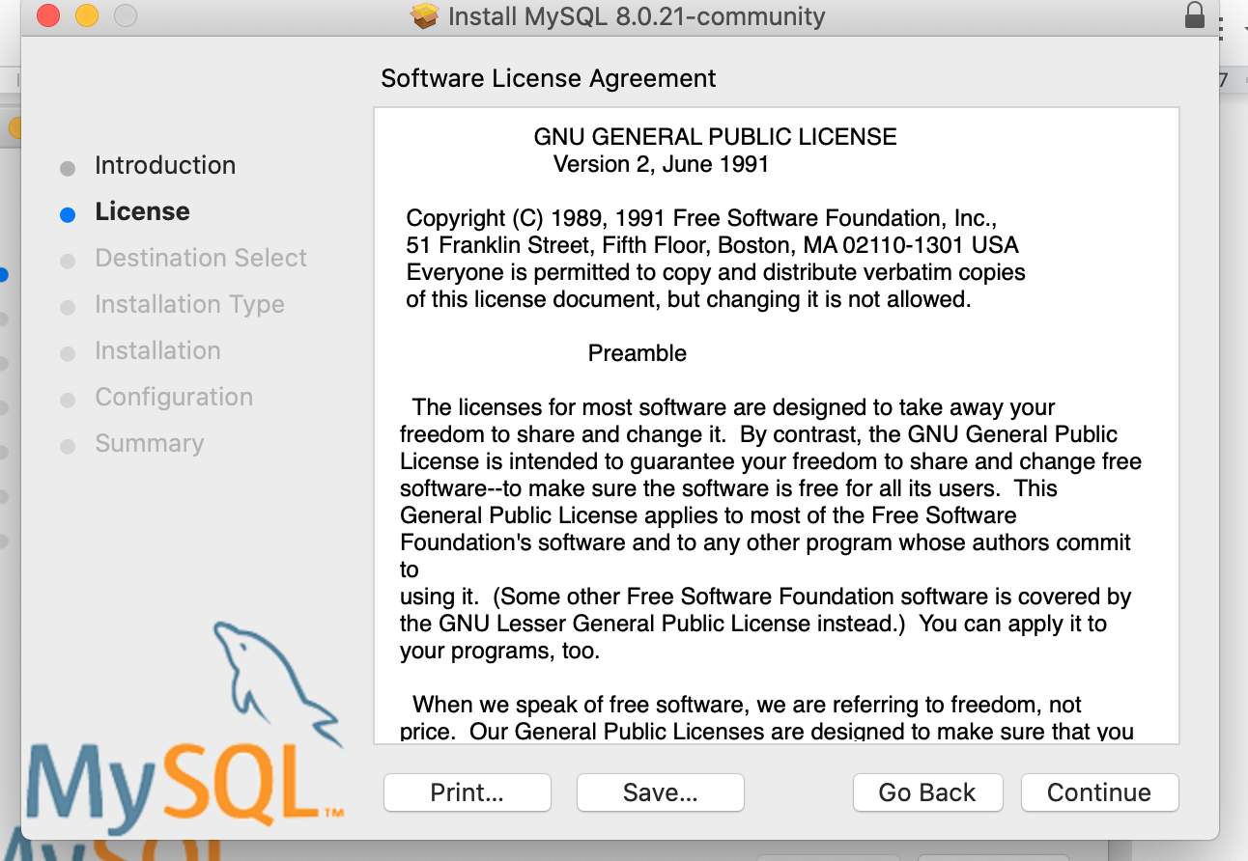

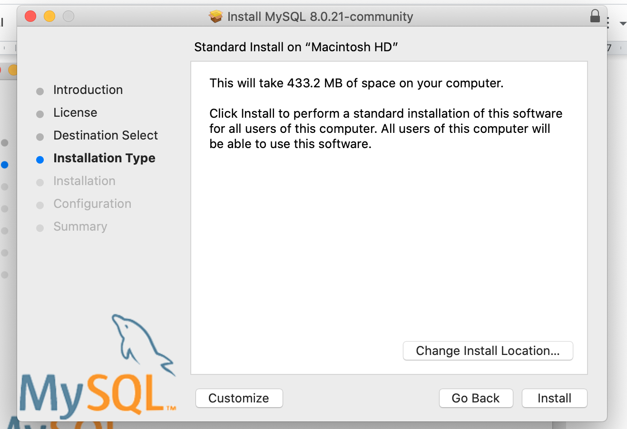

Keep default choice

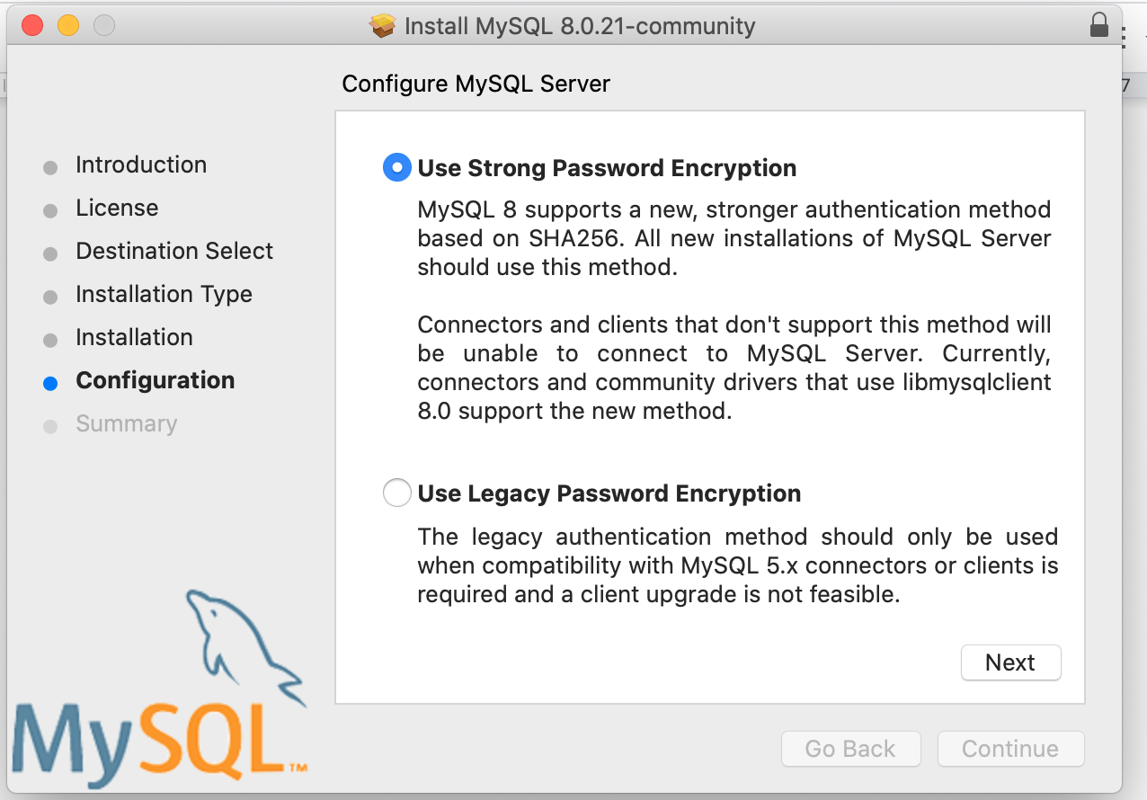

Choosing password for root user in MySQL

Type following password

**Buan6320 or something you can remember.**

**I always use coursecode**

(PLEASE use the above password, if you are using a different password make sure to REMEMBER). We need this to start and troubleshoot database issues.

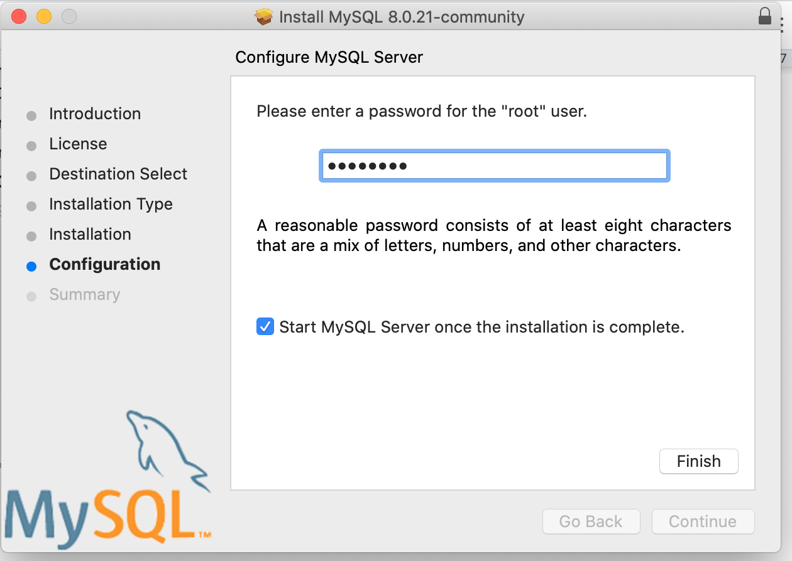

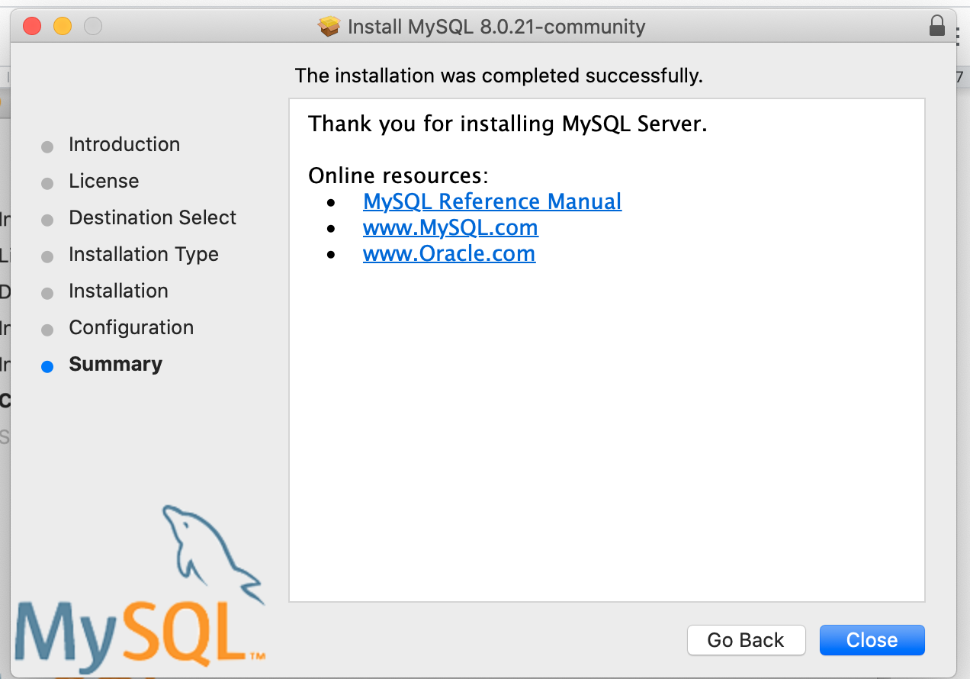

Finish the install.

**MySQL Server Install Complete**

**MySQL Workbench**

**Download Locations:**

***OPTION 1 :*** I have already downloaded to My google drive, Please use this link.

MySQL workbench 8.0.25 or latest version

<https://drive.google.com/file/d/1qGrhq77f1I5HyyBUHeDpuLFacS3cxVRm/view?usp=sharing>

**OPTION 2 :** If the link has any issue, use the following original location to get the software. You will be asked to create an account with oracle.com when you download the software.

<https://downloads.mysql.com/archives/workbench/>

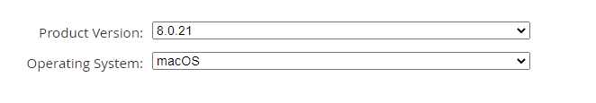

Packages for Catalina (10.15) are compatible with Mojave (10.14)

<https://downloads.mysql.com/archives/get/p/8/file/mysql-workbench-community-8.0.21-macos-x86_64.dmg>

Some MAC will have issues for 8.0.21, then download 8.0.19 version or older one

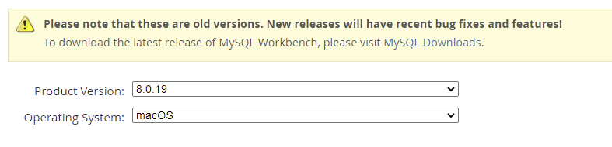

<https://downloads.mysql.com/archives/get/p/8/file/mysql-workbench-community-8.0.19-macos-x86_64.dmg>

This is simple install, open a DMG file and follow the instruction to copy the Mysql workbench to Application.

If you get above message and not able to open the file, go to

System Preference -> Privacy & Security -> General Tab will have message asking to “open file anyway”

**Install verification**

**Starting MySQL workbench**

Click on **Launchpad** in mac menu.

Look for **MySQL Workbench and click.**

Following screen will come

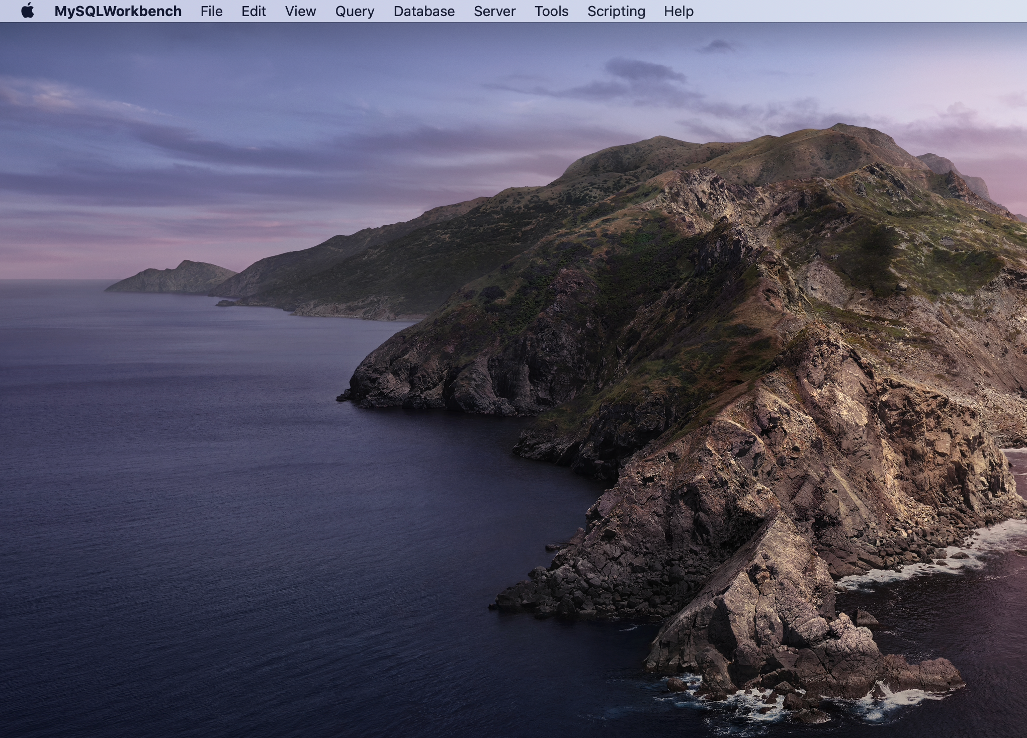

Click on **Database**

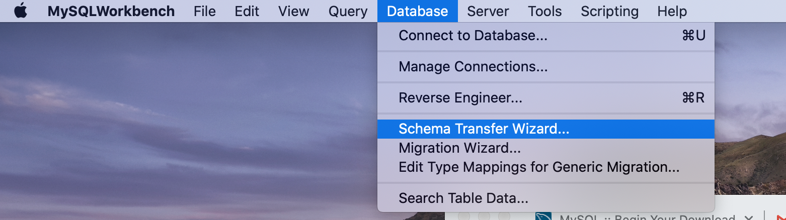

First time password will be asked, type the password (buan6320)

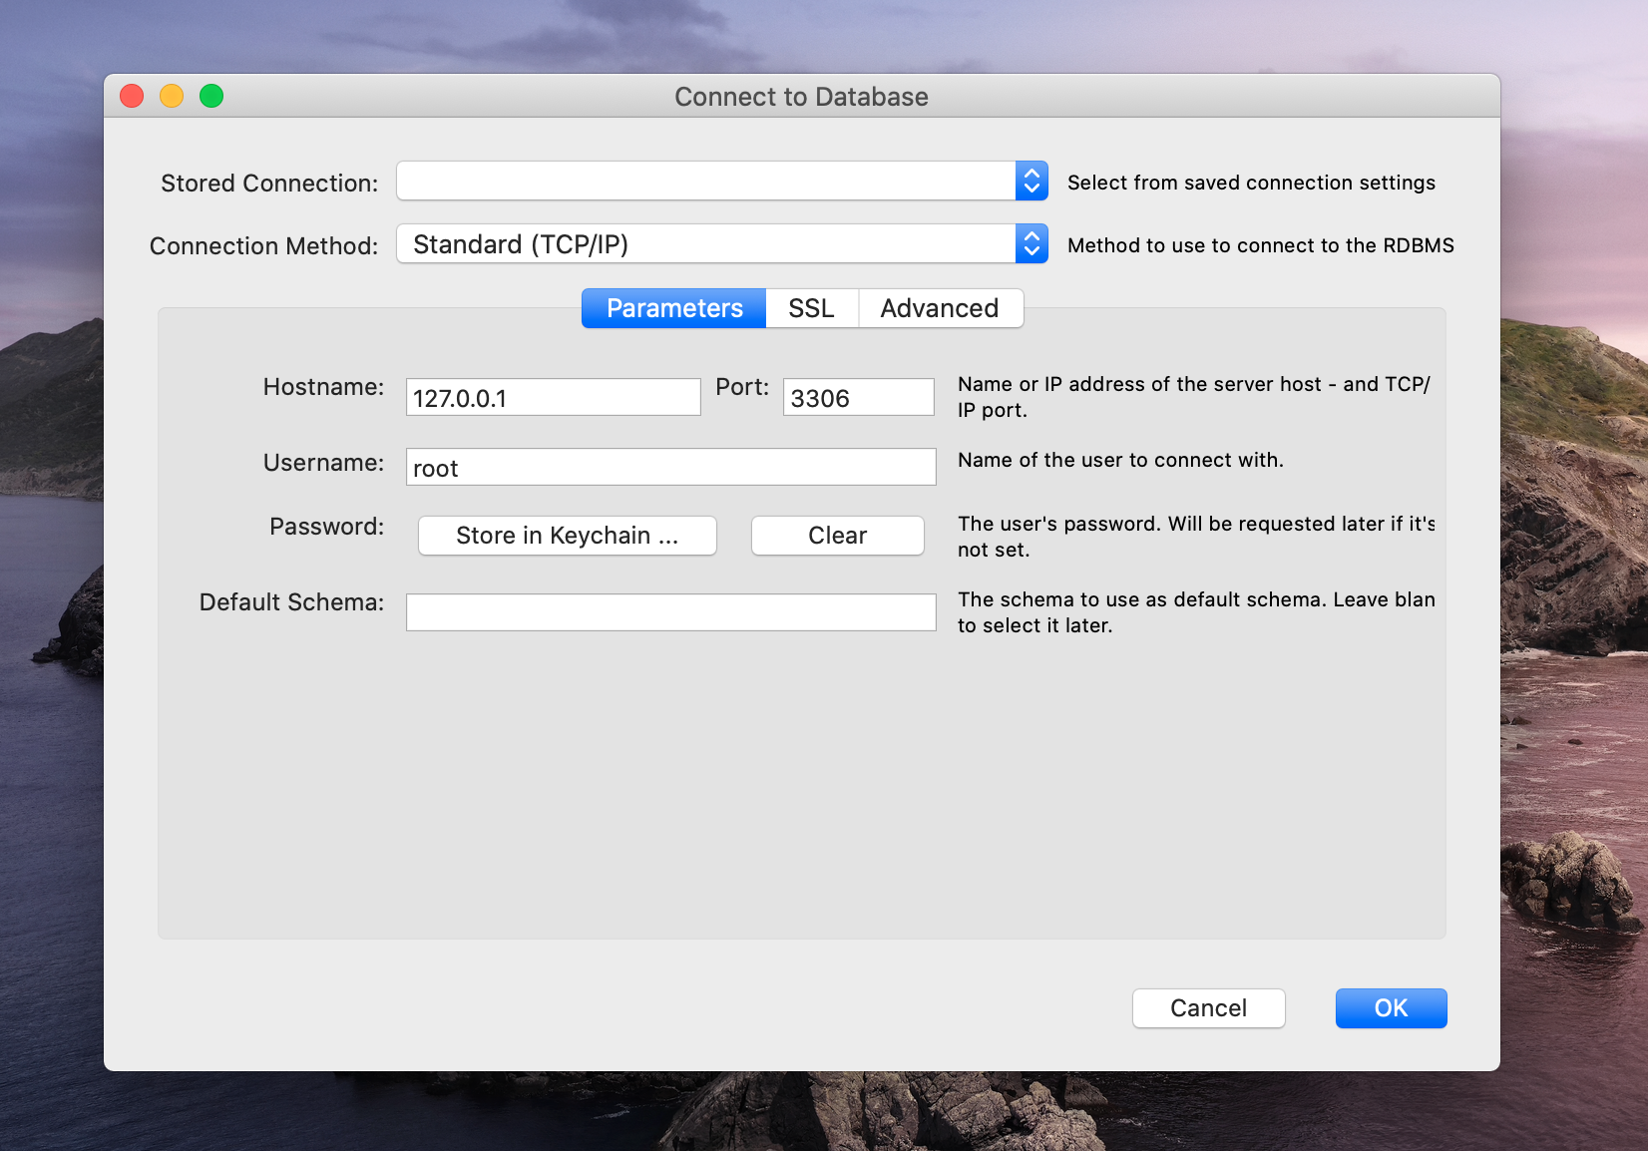

**Following screen will show, This is called Query Editor.**

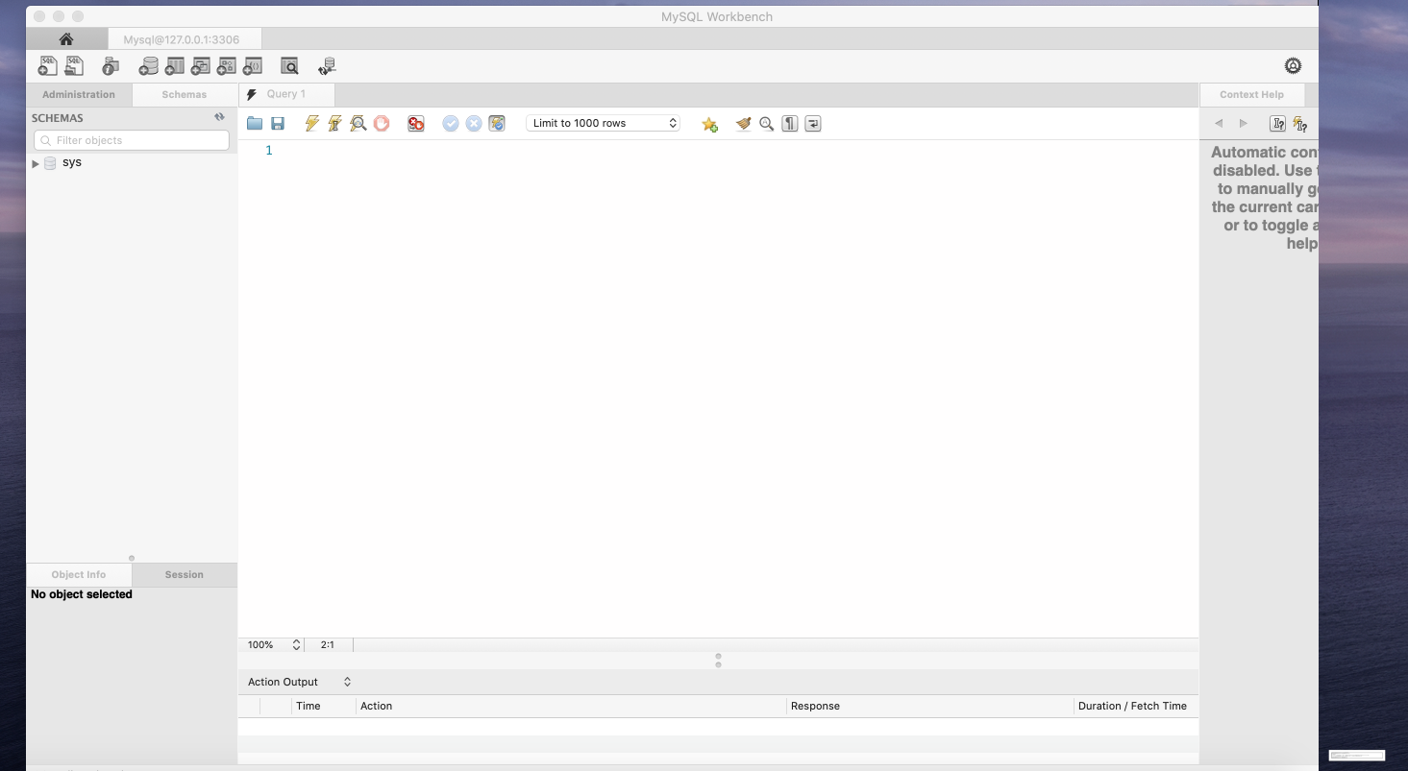

**Upload install verification to LAB 1**

In the screen

type following command in query editor

Select @@hostname, current_time, current_date;

And press 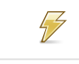 ( Execute button)

Result output will show your machine name.

Upload the screen**(just one screen only )** like this from your machine to

**LAB 1 in In-class Exercise Section of eLearning.**

